TITle (Times New Roman, 13, bold, centered, followed by a single space -13)

Firstname LASTNAME *, Firstname LASTNAME, Firstname LASTNAME (name of authors in Times New Roman, 9, bold, centered, LAST NAME OF AUTHORS UPPERCASE; if there are more authors from different institutions indicate them by numbering with superscript Arabic numbers, put an asterisk as superscript after the name (and number) of the corresponding author )

Department, Faculty, University, full postal address Times New Roman 9, italic, centered, single space-9 from the e-mail address

* e-mail address of the corresponding author, written in Times new Roman, 9, normal, centered, double space from abstract

The abstract is expected to be concise single paragraph, and to reflect the aim, methodology, findings and conclusions of the manuscript. The abstract will be written with Times New Roman, 9, italic, starting at 10 mm tab distance each paragraph, italic, single space.

Key words: please list at least 4, separated by commas, starting at left and justified, normal text with Times New Roman 9.

introduction

The language of the journal is English. Authors are kindly asked to use, where available, the Autocorrect function of the word processing software; the preferred spelling is US English.
References should follow the format (Aschner et al., 1999), or (Shinotoh et al., 1997; Yamada et al., 1986). Thus, they should be in brackets (name of the author, year of publication; names of both authors if only two, year of publication; name of the first author et al., in case of more persons, year of publication). Please note that at the end of the manuscript the reference list is ordered alphabetically, rather than based on the order of appearance in text.
introduction; materials and methods; results and discussions; conclusions; references will be written WITH Times New Roman 9, BOLD, centered, with a line SPACE TOWARD THE STARtING TEXT, twice the New times Roman 11 space toward the text above section

materials and methods

Experimental information is listed here, with enough detail to allow any colleague to reproduce the experiments and obtain similar results.
Ethical statements are expected here as well, where applicable.

results and discussion

The Results and Discussion section is expected to contain figures and/or tables numbered consecutively in Arabic numerals (e.g., Fig. 1, Table 1).
The length of the manuscript and the number of figures and tables are not restricted, as long as they fit within reasonable limits.

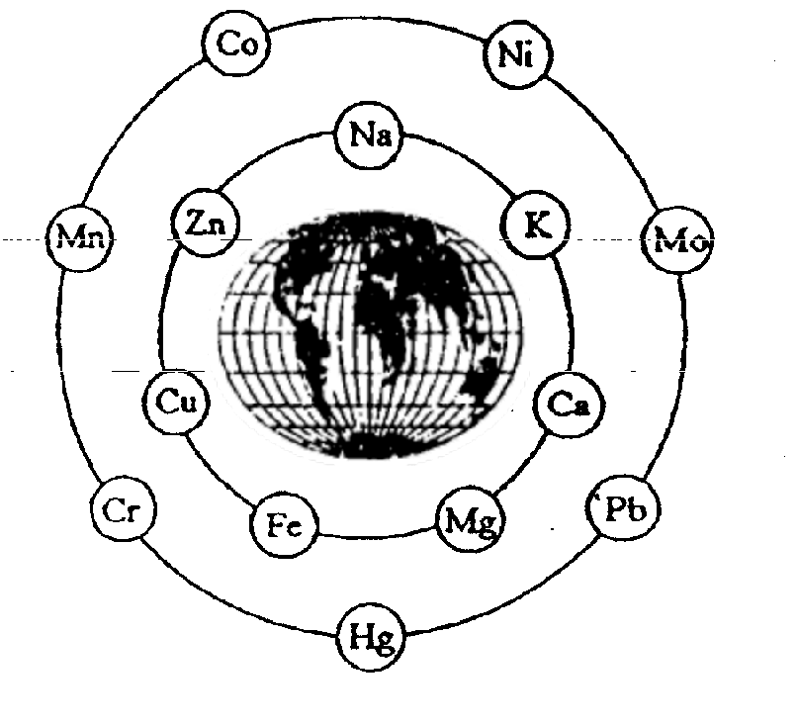
Fig. 1. Legend of the figure.

Figures (*.jpg form max. 500 KB per each picture) must be placed after statement made in text, at the appropriate points. The legend of the figure will be at the bottom of figure, abbreviated as Fig.X. written with Times New Roman 9 bold, left alignment; Legend of the figure Times New Roman, 9, normal.

- Table title must be places at the top of the table, in a separate row, written with Times New Roman 9, starting at the left margin of Table. Table footnotes must be included in a separate row of the table at bottom and written with Times New Roman 8,5.

CONCLUSIONS

A paragraph dedicated to conclusions, or a separate section identified as such, is expected at the end of the paper.

Acknowledgements (Times New Roman 9, bold, starting at the left margin). Brief acknowledgements should be placed here, including funding sources, grant number a.o. with Times New Roman, 9, normal, justified.

references
- Adriano D.C. – Trace elements in terrestrial environments: biogeochemistry, bioavailability and risks of metals, 2nd edition, Springer-Verlag, New York-Berlin-Heidelberg, 2001.
- Aschner M., Vrana K.E., Zheng W. - Manganese uptake and distribution in the central nervous system (CNS), NeuroToxicol, 1999, 20, 173-180.
- Beck B.D., Rudel R., Calabrese E.J. – The use of toxicology in the regulatory process, pp. 19-58, in „Principles and Methods of Toxicology”, 3rd edition (Hayes A.W., Ed.), Raven Press Ltd., New York, 1994.
- Brouillet E., Conde F., Beal M.F., Hantraye P. - Replicating Huntington's disease phenotype in experimental animals, Prog. Neurobiol., 1999, 59, 427-468.
- Coles C.J., Edmondson D.E., Singer T.P. - Inactivation of succinate dehydrogenase by 3-nitropropionate, J. Biol. Chem, 1979, 254, 5161-5167.
- Hazell A.S., Norenberg M.D. - Manganese decreased glutamate uptake in cultured astrocytes, Neurochemistry, 1997, 22, 1443-1447.
- Lukács A., Szabó A. - Functional neurotoxic effects of heavy metal combinations given to rats during pre- and postnatal development, Centr. Eur. J. Occup. Environ. Med., 2007, 13, 299-304.
- Nordberg G.F., Fowler B.A., Nordbrg M., Friberg L. (Eds.) – Handbook on the Toxicology of Metals, 3rd edition, Elsevier, Amsterdam, 2007.
- Shinotoh H., Snow B.J., Chu N.S., Huang C.C., Lu C.S., Lee.C., Takahashi.H., Calne D.B. - MRI and PET studies of manganese intoxicated monkeys, Neurology 1997, 45, 1199-1204.
- Smith S.J., Harding A.E. - EEG and evoked potential findings in mitochondrial myopathies. J. Neurol. 1993, 240, 367-372.
- Tavares R. G., Santos C. E., Tasca C. I., Wajner M., Souza D. O., Dutra-Filho C.S. - Inhibition of glutamate uptake into synaptic vesicles from rat brain by 3-nitropropionic acid in vitro, Exp. Neurol., 2001, 172, 250-254.
- Yamada M., Ohno S., Okayasu I., Okeda R., Hatakeyama S., Watanabene H., Ushio K., Tsukagoshi H. - Chronic manganese poisoning: a neuropathological study with determination of manganese distribution, Acta Neuropathol., 1986, 70, 273-278.
- Williams R.J.P. – Bio-inorganic Chemistry and cancer, pp.19-38, in „Carcinogenicity of inorganic substances : Risks from Occupational Exposure” (Duffus J.H., Ed.), The Royal Society of Chemistry, Cambridge, 1997
- Zhang S., Zhou Z., Fu J - Effect of manganese chloride exposure on liver and brain mitochondria function in rats, Environ. Res., 2003, 93, 149–157.
- *** - Commission Regulation (EC) No 1881/2006 setting maximum levels for certain contaminants in foodstuffs, Official Journal of the European Union, L 364, 20, 12.2006
- *** - http://www.codexalimentarius.org (accessed on October 5, 2011)

GENERAL REQUIREMENTS
Page setup : paper size A4 ; margins - top 1″, bottom 1″, left and right 1.57″; layout - header 0.5″, footer 0.5″

Please note that although initial submissions are accepted in any format, the final version of the accepted manuscript will be *.doc.

