FACULTATEA DE CHIMIE ȘI INGINERIE CHIMICĂ
Str. Arany János nr. 11, Cluj-Napoca, RO-400028
Tel.: 0264-59.38.33; Fax: 0264-59.08.18
www.chem.ubbcluj.ro; chem@chem.ubbcluj.ro

Guide and technical requirements for writing an MSc dissertation – for the MMCB specialization-

Contents
Comments on choosing your topic 1
Technical requirements for the document 1
Public defense 2
UBB policy on credit and authorship for team research 2
General comments about writing your dissertation – beginner’s guide 2

Comments on choosing your topic
The dissertation is expected to cover a topic illustrated by the name of the specialization (i.e., Molecular Modeling in Chemistry and Biochemistry). In general, this implies work of a theoretical nature, rather than experimental. However, combined experiment-theory works are also encouraged. The candidates are in either case expected to use the dissertation as an opportunity to showcase their knowledge of molecular modeling and of chemistry or biochemistry.

Technical requirements for the document
The dissertation should be structured similarly to a scientific article.

Length: 25-30 pages for the actual scientific content (Introduction through Conclusions; not counting the Title page, Contents page, Acknowledgement, Appendices etc), size A4 with normal margins, Times New Roman 12 spaced at 1.5.

Title page: should list the title of the dissertation, the names of the student and of the coordinator(s), the name of the institutions (University, Faculty), the name of the specialization, and the year.

Foreword page (optional)
Contents page (optional)

Abstract – half a page

Introduction – describing the context, literature study, and ending with a brief presentation of the aims of the research described in the dissertation. Expected to occupy ~1/3 of the length of the dissertation.

Materials and Methods (or variations thereon – e.g. Theoretical Methods, Experimental etc) – listing the instrumentation/hardware, software, techniques, other technical details.

Results and Discussion (may optionally be separated into two separate sections)

Conclusions

Acknowledgments (optional, may also be listed as Foreword)

References (or variations thereon, e.g. Bibliography): at least 10 references from the past 10 years should be included. Reference style: follow the recommendations of the journal Studia UBB Chemia.

Appendices (optional) – data, text etc that is relevant to or supports the contents of the dissertation.

Public defense
The dissertation will be defended publicly in front of an examination committee. A powerpoint-type presentation is expected, with 7 minutes allocated to the student’s presentation and 8 minutes allocated to questions from the committee.

UBB policy on credit and authorship for team research
Students and their advisors are expected to follow UBB’s Scientific Council policy regarding research results obtained in combined/team efforts and the (re)use of research already published in scientific journals, books or otherwise – see https://cercetare.ubbcluj.ro/ro/cercetarea-la-ubb/consiliul-stiintific/

General comments about writing your dissertation – beginner’s guide
- The text should be written in uniform font. Different fonts can be used for titles, subtitles, author names, author affiliation.
- The text will be written in whole sentences, with subject and predicate, using as rarely as possible dashes, bullets, or similar elements. The text will be more presentable if the "Justify" option is used, as long as it is applied to the entire text and not just to some paragraphs.
- The text must be original, written personally by the author. We do not accept whole sentences taken word for word from other authors. Where ideas of other authors are reproduced, this shall be stated by citation. For example, a number is inserted at the end of that sentence after the format [1], and at the end of the report a list entitled "references" or "bibliography" will be provided, in which the source is extensively given. For example:
1. Alayash, A. I. Nat Rev Drug Discov, 2004, 3, 152-9
2. Chen, J. Y.,Scerbo, M.,Kramer, G. Clinics (Sao Paulo), 2009, 64, 803-13
3. Mot, A. C.,Roman, A.,Lupan, I.,Kurtz, D. M., Jr.,Silaghi-Dumitrescu, R. Protein J, 2010, 29, 387-93
4. http://chem.ubbcluj.ro/pagini/biochimie/radu/565web_rom.htm, accessed 2011-12-03
5. Silaghi-Dumitrescu, R., Metals in living systems, Cluj University Press Publishing House, Cluj-Napoca, 2011

- If there is a need to reproduce word for word phrases written by other authors (for example, a famous quote), that phrase should not only be quoted as shown above, but also put in quotation marks (or, in other areas, written in a special font identifying it as such). It is also not recommended to use figures drawn by others; if they come from publications available commercially (e.g., books, magazines), the consent of the author or publisher must be sought before using them; if they are from a free source like Wikipedia, then that source should be cited. However, it is preferable in all cases to draw your own figures; If what you drew is actually a copy of something from literature, the original figure also needs to be cited.
- Generally, figures are labeled by a short informative text, written underneath the figure; for example:
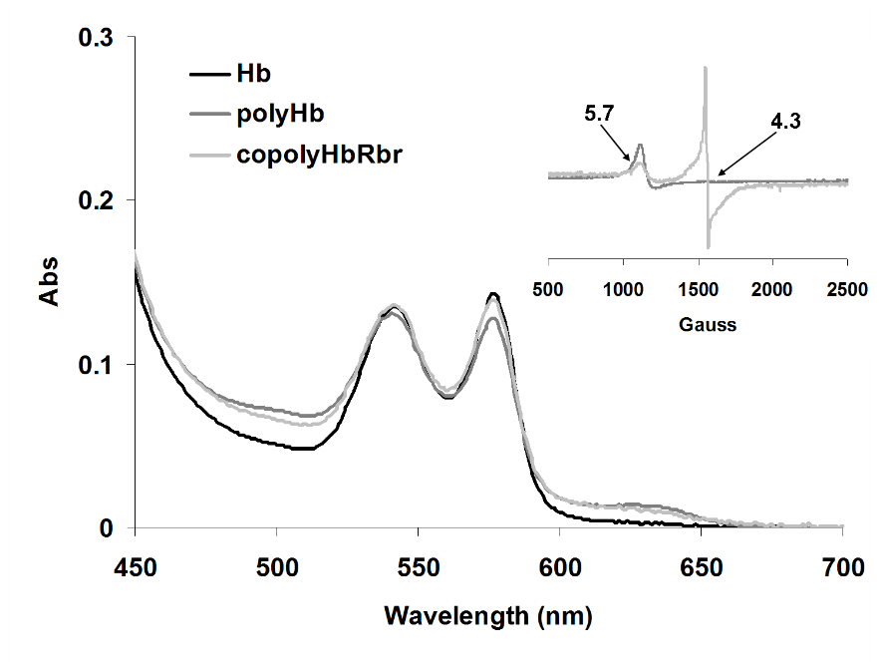
Figure 1. UV-vis absorption spectra of hemoglobin cross-linked with glutaraldehyde in either the absence or presence (“copoly”) of Rbr for 1:30 mixture, PBS buffer, pH 7.4. Inset shows corresponding EPR spectra of the copolymers high molecular weight fractions and the g values are indicated by arrows.

- It is inadvisable to include the title of the figure in the figure. An example of of what you should NOT do:
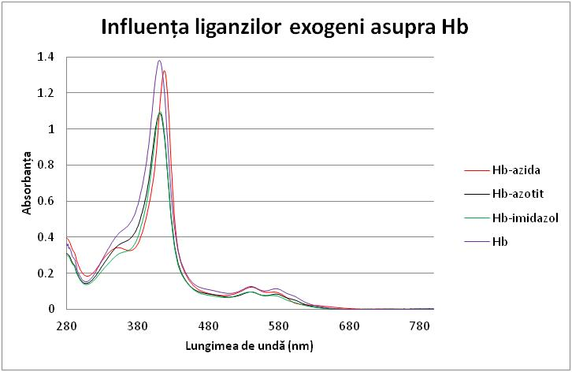

- It should also be noted that the labels of the figures in the manuscript must also contain a number (for example, the figure above is labeled as Figure 1). Where the figure lists schematic elements, it may also be labelled as a "Scheme". In Schemes usually, unlike Figures, there is no need for a text explaining anything; thus, the schemes will be labeled with the format "Scheme 1", :Scheme 2", etc. Similarly to Schemes, you can use "Chemical Reactions". Tables must also have headings, following the format "Table 1. Values of activation energies for the reactions studied in this paper". The title of the Table is usually placed above the Table.
- It is recommended that the format of the figures be unitary. The text inside them will be as much as possible in the same type of font, as unitary as possible. For example, if three different Figures list UV-vis spectra, then the axis labels in all figures (Absorbance, wavelength) must be the same in all figures in terms of font, size and, if applicable, abbreviation. Also, the thicknesses and type of lines used for axes or other elements should be similar in all figures. Charts in Excel tend to have a series of horizontal lines by default; in most cases those lines are useless and can be removed (simply click on one of them and press the 'delete' button on the keyboard).
- Any Figure, Diagram, or Table must be explicitly mentioned at least once in the text. For example, "Figure 3 shows the UV-vis spectra of myoglobin at various pH values. It can be concluded that...", or "bond length values are strongly affected by these factors, as shown in Table 3".
- In figures, the space covered by graphs must be carefully chosen to present only useful information and not include unnecessary white spaces. For example, there are types of experimental methods, such as UV-vis spectroscopy, in which there are no negative values on the y-axis of a graph; In this case, care must be taken to ensure that the Y-axes start from zero, not from negative values. In the same example, if we have x-axis measured values between 400 and 800, the graph should not extend below 400 or above 800.
- The two graphs below contain black borders around the figure; These borders are unnecessary and usually need to be removed. To the right of each chart is what in Excel is called "Legend". In the first figure, this Legend makes sense, because there are two data sets in the graph - the 'practical' and the 'theoretical' one. In the second figure the Side Legend does not make sense, because there is only one curve, the one labeled 'CO', and the identity of this curve will anyway be established in the label which will have to be below the Figure as shown above ("Figure 3. UV-vis spectrum of myoglobin-CO complex").
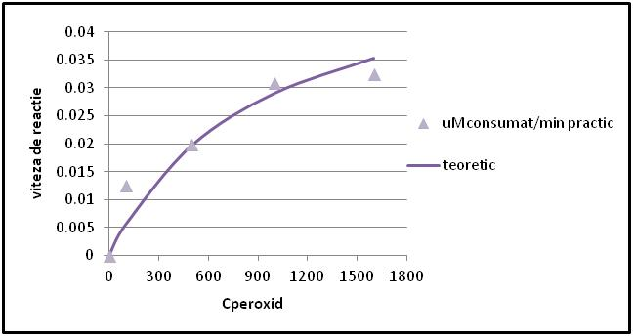
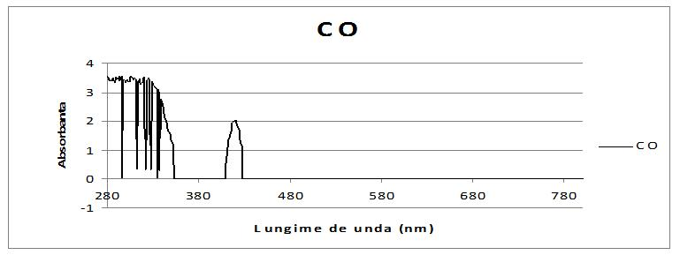

- In writing the Results and Discussion section, the author must aim to convince the reader that the data presented in the Figures and Tables mean something, and that they lead to a specific conclusion. Therefore, very concrete references must be made in the text, as far as possible with numerical data, to Figures and Tables; If necessary, data from literature can also be cited, specifying the source. The emphasis will therefore be on a rigorous demonstration, with arguments, and not on the direct statement of conclusions; This is an important difference from a theoretical exam that is taken upon completion of a college course: while the teacher reading the exam paper "knows everything" about the subject, it is assumed that the reader of the scientific report sees these results for the first time and knows no more about the subject than the author themselves knows. From this point of view, the author, who made the experiment with their own hands, often alone in the laboratory, has a special responsibility to explain to readers what happened in those experiments; In some sense, there are things out there that the author is the only person who knows, and no one else can explain them correctly to readers.
- Between sizes and units of measurement, there is usually a free space. Thus "450 nm" is correct, but not "450nm". Also, "pH 5", not "pH5".
- Some scientific terms, such as "pH", begin with lowercase; They will be written this way even when they represent the first word in the sentence
- Before the comma, period, semicolon, colon and other punctuation marks, no blank space shall be left. After them, a free space is left. When we open a parenthesis, we leave a blank space before it but not after it. When we close a parenthesis, we leave a blank space after it but not before it (unless a punctuation mark follows it, in which case no free space is left either before or after the closed parenthesis)
- It is preferable to describe experiments and results impersonally, or in the third person. Thus, preference is given to wording such as "Table 5 shows the data...", "The measurement was made...", "It is found that", instead of "In Table 5 we present", "We have made the measurements..." or "We find that"
- For the blank space at the beginning of a new paragraph, a sequence of blanks rather than using the Tab key or the the Space key, rather change the automatic text settings
- Decimal separators inside numeric values must conform to the language in which the report/text is. For example, what in Romanian is written as 3,14, in English is written 3.14 (with comma in Romanian, with period in English). This should be followed especially when copying tables and numerical values from calculation programs such as Excel, where the default language may be English while the report is in Romanian (or vice versa).

